 | S5 B Test, June 2023  Teachers : M. A. COSTA MOLINA, A. FIELDING, A. HARSANYI, A. C. LENTI, O. PICAUD, S. ANGELOZI, S. F. SOLANDER, J. SZUTY, L. WURZER.

MatHEMATICS 4 périodS
Part A

Date : 14 June 2023
Name : _____________________________
Class : __________________
Score : _____ / 20
Duration of Test :  45 minutes : 8h30 - 9h15  AUTHORIZED MatériAl :  NON-CaLCULATOR  Pencil  Ruler  Special REmarks : | 
- The subject includes 4 compulsory exercises.
- The answers must be accompanied by the explanations necessary for their elaboration.
- Full points cannot be awarded for a correct answer in the absence of the reasoning and explanations that lead to this answer.

Stay calm and focused.
Good job and good luck.
Exercice A1 | Marks
Let $f(x)$ be the function defined by $f\left(x\right)=2^{x}$.
1) Complete the table of values below :  $$x$$ -3 -2 -1 0 1 2 3  $$f\left(x\right)$$ | 2 points
2) Sketch a graph of the function $f(x)$ below : | 2 points
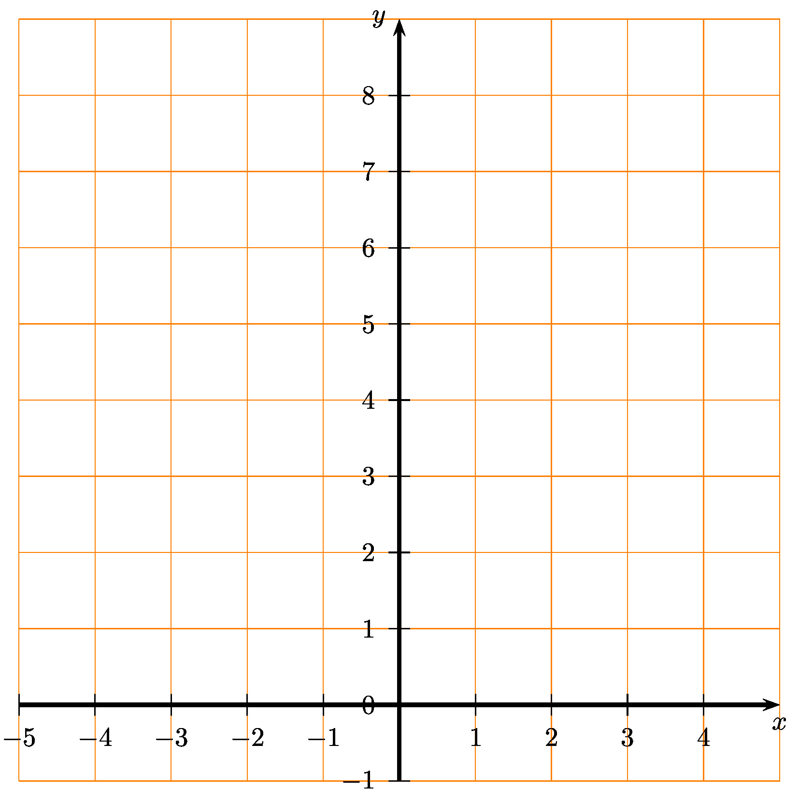
3) Discuss if the function $f(x)$ is representing exponential growth or decay. Justify. | 1 point

Exercice A2 | Marks
1) Match each angle in degrees (from a to e) to the corresponding angle in radians (from i to v) :  a) 90° b) 30° c) 300° d) 270° e) 135°  i) $\frac{5}{3}π$ ii) $\frac{1}{2}π$ iii) $\frac{3}{4}π$ iv) $\frac{1}{6}π$ v) $\frac{3}{2}π$ | 2,5 points
2) Place these five angles on the Unit Circle below.
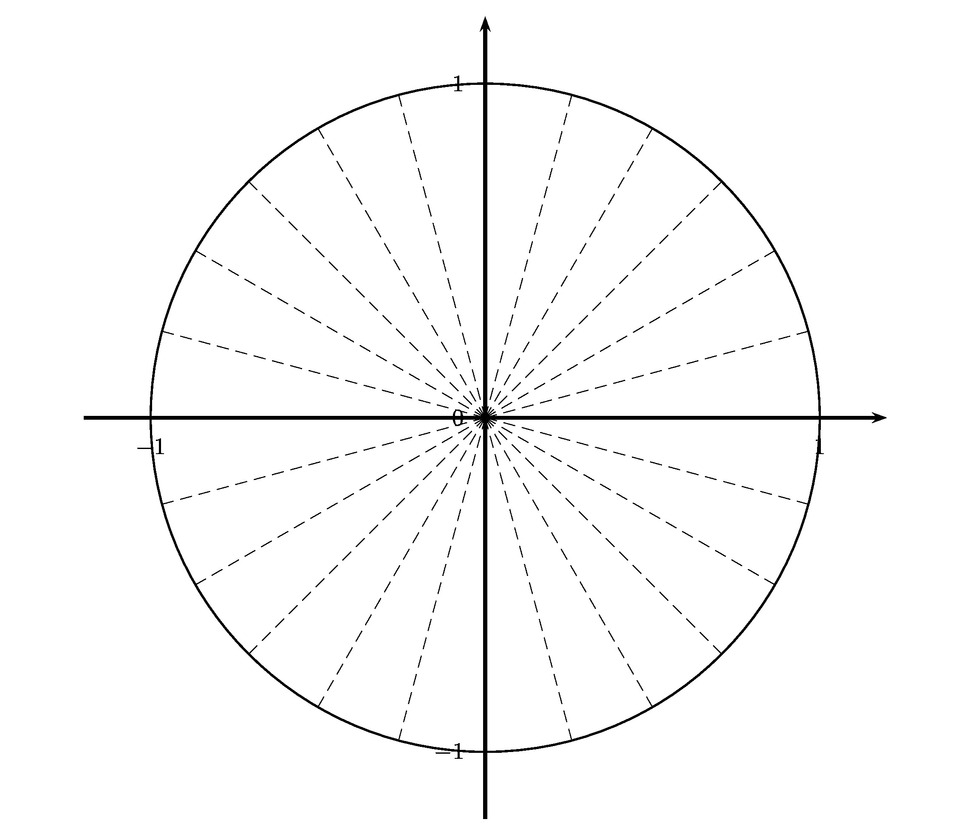 | 2,5 points

Exercice A3 | Marks
We have put together the December B tests in mathematics, for S5 pupils of EEB1. Among those tests, we look at the grades of 6 students. Their 6 marks were as follows:
5 ; 5 ; 6 ; 6 ; 6 ; 8
1) Calculate the mean of these 6 marks. | 1 point
2) Check that the standard deviation of these 6 marks is 1. | 2 points
3) In another group of students, the mean is the same but the standard deviation is higher. Interpret this difference in terms of results of the two groups of students. | 1 point
4) Give an example of a series of 6 marks with the same mean, but with a higher standard deviation. | 1 point

Exercice A4 | Marks
1) Associate each function (from f to h) to the graph (from i to iii) :  $$f\left(x\right)=sin\left(x\right)$$ $$g\left(x\right)=cos\left(x\right)$$ $$h\left(x\right)=tan\left(x\right)$$ | 3 points
i)
ii)
iii)

2) Give the périod of the functions i) and ii). | 2 points

END OF THE EXAMINATION

