 | S5 B Test, June 2023  Teachers : M. A. COSTA MOLINA, A. FIELDING, A. HARSANYI, A. C. LENTI, O. PICAUD, S. ANGELOZI, S. F. SOLANDER, J. SZUTY, L. WURZER.

MathématiCs 4 périodS
Part B

Date : 14 June 2023
Name : _____________________________
Class : __________________
Score : _____ / 20
DurATION OF TEST :  45 minutes : 10h00 - 10h45  AUTHORIZED MatériAl :  Examination with technological tool: Calculator Casio Graph 90+E, Numworks or TI-83 Premium CE Python in exam mode.  Pencil  Ruler  Remarques particulières : | 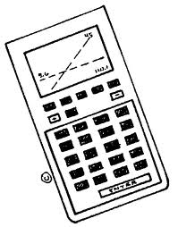
- The subject includes 4 compulsory exercises.
- The answers must be accompanied by the explanations necessary for their elaboration.
- Full points cannot be awarded for a correct answer in the absence of the reasoning and explanations that lead to this answer.

Stay calm and focused.
Good job and good luck.
Exercice B1 | Marks
Medical doctors often use radioactive iodine a tracer when diagnosing some thyroid gland disorders. The iodine decays in such a way after $t$ days, the amount left is given by :
$$A\left(t\right)=6⋅{0.917}^{t}$$
where $A\left(t\right)$ is measured in grams.
1) Calculate the initial amount of iodine. | 1 point
2) Calculate how much iodine remains after 15 days (round to two decimals) | 1 point
3) Calculate the date when the amount of iodine drops below 1 gram (round to 1 day). | 2 points
The diagram below shows the elimination of iodine from the body:
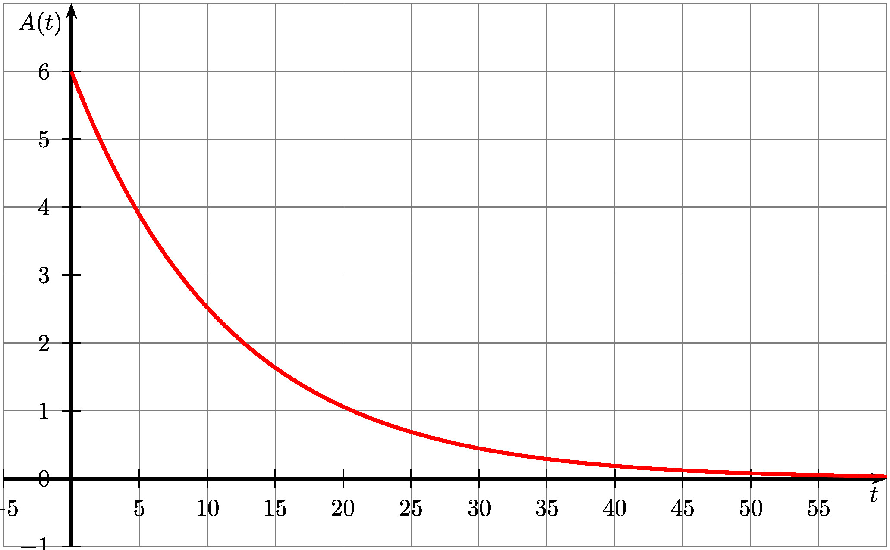
4) Based on this graph and the expression of the function, explain why the iodine is not completely removed from the body. | 1 point

Exercice B2 | Marks
An athlete, specialist in the shot put, participates in the eliminatory events with a view to his possible selection for the European championships. He is required to make 12 throws, the lengths of which, in meters, are given below:
18.6, 19.4, 20.8, 15.9, 17.7, 21.1,
19.8, 15.2, 17.2, 16.5, 20.5, 21.9
1) Find the mean of the series of throws. Interpret this result with a sentence. | 1 point
2) Find the median of the series of throws. Interpret this result with a sentence. | 1 point
3) Determine the quartiles of the series of throws and draw the box-plot. | 2 points
Another athlete has also made 12 throws, and the box and whiskers plot of those throws, in meters, are given below :
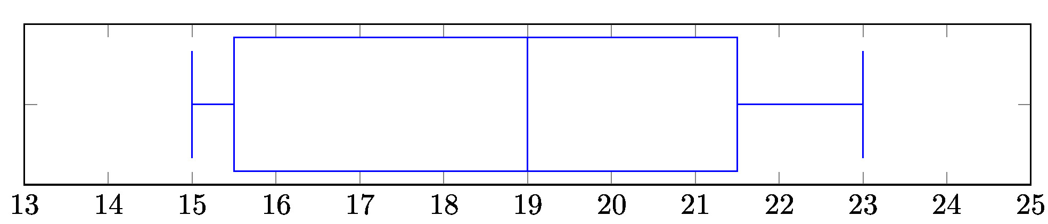
4) Compare the series of throws of those 2 athletes. | 2 points

Exercice B3 |  |  | Marks
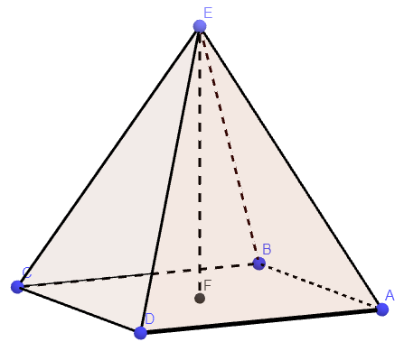 |  | The Louvre pyramid in Paris is a regular square-based pyramid of 21.6m height. The square base measures  35 m each side. The triangular faces are made of glass.  The formula for the volume of a  pyramid is:$\frac{1}{3}×area of base×height$
1) Calculate the volume of the space enclosed in the pyramid. |  |  | 1,5 point
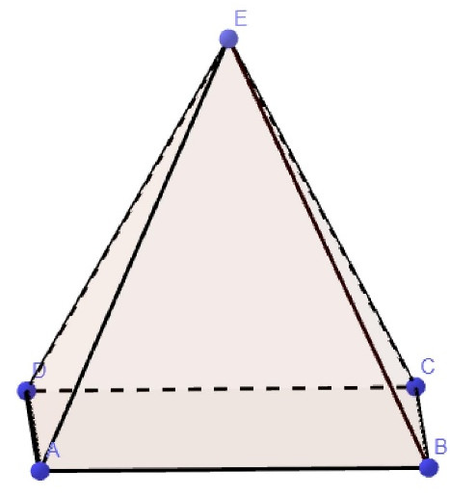 | H is the midpoint of [AB].
 | 2) In the diagram opposite, represent [EH], the height of the triangle ABE from E (by coding the figure), then show that EH = 27.8 m, rounded to tenths of a meter. |  | 1 point
 | 3) Calculate the area of the glass. |  | 1,5 point
4) The Louvre pyramid is a reduction of the Cheops pyramid in Egypt. The base of the Cheops pyramid has a side that measures approximately 230.5 m. Show that the height of the Cheops pyramid is approximately 142.3 m. |  |  | 1,5 point

Exercice B4 | Marks
The balloon in the image is tied to the ground with a 50 meter rope.
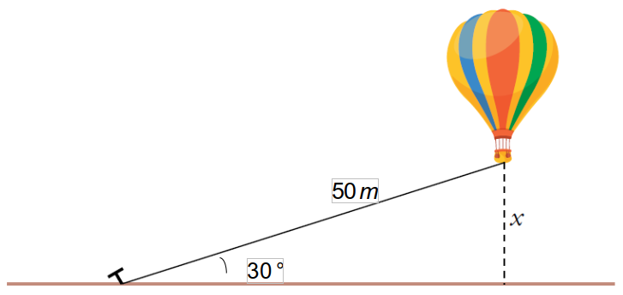
Calculate the distance between the ground and the bottom of the balloon basket. | 3,5 points

END OF THE EXAMINATION

