 | S5 B Test, June 2024  Teachers : S. ANGELOZI, S. KWASNY, A. C. LENTI, H. PÁSZTOR, M. PÉREZ PÉREZ, S. F. SOLANDER, R. SOUISSI, L. WURZER.

MatHEMATICS 4 périodS
Part A

Date : 17 June 2024
Name : _____________________________
Class : __________________
Score : _____ / 35
Duration of Test :  45 minutes : 13h00 - 13h45  AUTHORIZED MatériAl :  NON-CaLCULATOR  Pencil  Ruler  Special REmarks : | 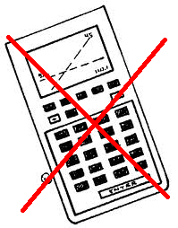
- The subject includes 4 compulsory exercises.
- The answers must be accompanied by the explanations necessary for their elaboration.
- Full points cannot be awarded for a correct answer in the absence of the reasoning and explanations that lead to this answer.

Stay calm and focused.
Good job and good luck.
Exercice A1 | Marks
In a certain country the growth of a certain rabbit population (per week) can be modelled with the following function:
$$f\left(x\right)=100∙2^{x}$$
with $f(x)$ describing the number of rabbits after $x$weeks and $x=0$ being the time at the beginning of the observation of the rabbit population.
1) Give the number of rabbits, that have been in the country at the beginning of the observation. | 1 p
2) Calculate how many rabbits will live in the country after 1 week and after 3 weeks and compare the values. | 4 p
3) Sketch the graph of the function $f\left(x\right)$ for $x∈\left[0,5\right].$Use the sheet of graph paper you received at the beginning of the exam. | 2 p

Exercice A2 | Marks
Determine real numbers for which the following equations are true:
- $3^{x+2}=1$ | 2 p
- $5^{x-1}=\sqrt{5}$ | 2 p
- ${\left(\frac{1}{4}\right)}^{x}=64$ | 3 p

Exercice A3 | Marks
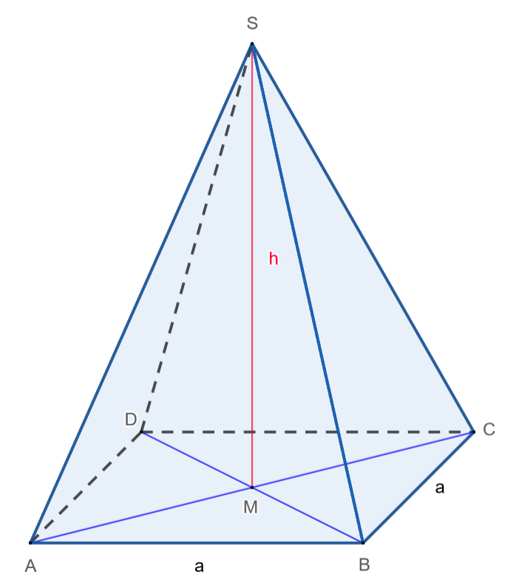
The figure shows a pyramid $ABCDS$ with a square base.
The base is $a=6 cm$ and the height of the pyramid is $h=4 cm$.

1) Given that the formula for the volume of a pyramid is  $$V=\frac{Base area∙Hight}{3}$$  calculate the volume of this pyramid. | 2 p
2) Calculate the height of triangle BCS. | 2 p
3) Calculate the area of triangle BCS. | 2 p
4) Calculate the surface area of this pyramid. | 3 p

Exercice A4 | Marks
1) Determine what each angle in degrees is equivalent to in radians: | 3 p
- 45° = ________rad
- 150° = _______rad
- 300° = ________rad
2) Determine what each angle in radians is equivalent to in degrees:  - $\frac{1}{3}·π$ rad= ________°  - $\frac{5}{4}·π$ rad = ________° | 2 p
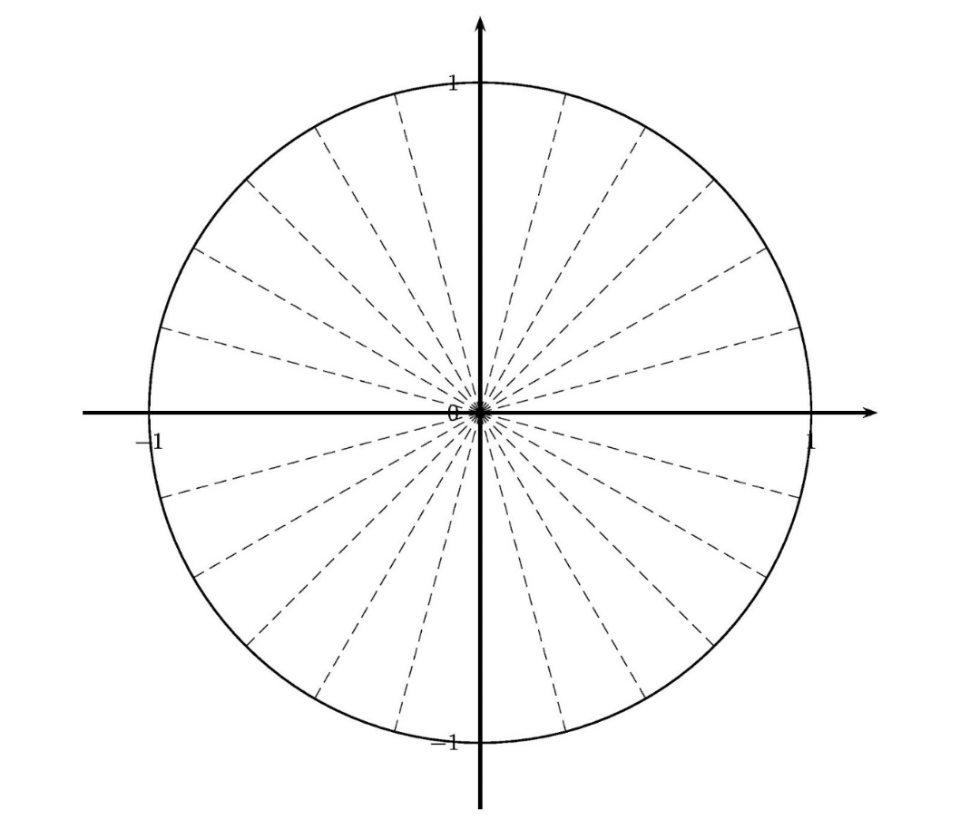  3) Insert those 5 angles listed above on the unit circle | 2 p
4) Given is $\cos\left(60°\right)=\frac{1}{2}$.  Based on this information find all the values of $α (0<α<360°)$ for which $\cos\left(α\right)=-\frac{1}{2}.$  Enter the answers in radians and plot it on the above unit circle. | 5 p

END OF THE EXAMINATION

