 | S5 B test, June 2023  Professors: P. ALBANO, S. CHOUDHARY,  B. DUROYON-MARCHAND, C. FOLMER JENSEN,  S. KWASNY, J. LEEB, H. PÁSZTOR, L. SÁNCHEZ BLÁZQUEZ, H. SIENIAWSKA, S. F. SOLANDER, R. SOUISSI.

Mathematics 6 periods
Part B

Date: June 14, 2023
Last name, First name: __________________________________
Class: S5MA6ENA
Marks : _____ / 41
Duration of the test:  1h30 minutes (90 minutes) : 10h00 - 11h30  Authorized Equipment:  Exam with technological tool: Casio Graph 90+E,  Numworks or TI-83 Premium CE Python calculator in exam mode.  Pencil for graphics  Ruler  Special remarks: | 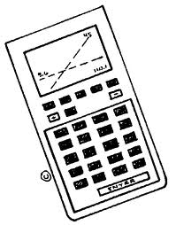
- The subject consists of 6 mandatory exercises.
- The answers must be accompanied by the explanations with relevant steps.
- All the points cannot be attributed to a correct answer in the absence of the reasoning and explanations that make it possible to arrive at this answer.
- The candidate must answer on the subject: empty spaces are left in each exercise to do this.

Stay calm and focused.
Good job and good success.
Exercise B1 | Points
The side view of the ramp represented by the image below is of a parallelogram shape. The vertical sides are 80 cm , their distance is 115 cm. The length of the other two sides is 125 cm. (We use the notation in the figure.)
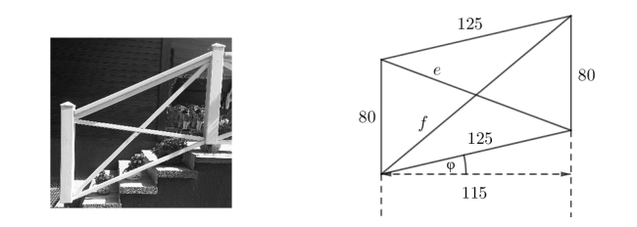
1) The angle φ is the angle formed by the horizontal and the lower side of the parallelogram. Prove with a calculation that φ= 23° (rounded to the nearest integer). | 1.5 points
2) Calculate the length of the diagonal of the parallelogram. | 2 points
3) A reed windbreak is installed on the ramp. Calculate the area of the reed breakthrough covering the parallelogram-shaped part. Discuss whether the area of the reed windbreak is less than 1 m². | 2.5 points

Exercise B2 | Scale
40% of a dentist's patients are men. The agenda of this dentist shows that 20% of men and 10% of women who make an appointment do not come to this appointment.
A person makes an appointment.
1) Determine the probability of:
(a) that person is a woman present at the appointment. | 2 points
(b) that person comes to the appointment. | 2 points
(c) that person is a man given that this person does not come to the appointment. | 2 points
53% patients of another dental practice are under 18 years old,
71% of patients wear glasses of which 47% are 18 years of age or older.
The following events are considered:
A: " The patient is 18 years of age or older"
L: " The patient wears glasses"
2) Determine whether events A and L are independent. Justify your answer. | 2 points

Exercise B3 |  | Scale
On the social media Twitter, we study the likes of three tweets during a period of time.
At the beginning of the study, the first tweet has 210 likes, and then, the number of its likes grows by 25% per hour.
1) Explain why the increase is exponential and why it can be modelled by the formula:  $$T_{1}\left(t\right)=210 {(1.25)}^{t}$$  Where t indicates number of hours after the starting time. |  | 1 point
2) Compute the number of likes that the tweet has after 24 hours. |  | 1.5 points
3) On the millimeter paper provided, draw the graph of the function T₁ for the first twenty hours after the tweet has been written. |  | 1 point
4) According to the model, compute the number of hours it takes for the tweet to reach 10 000 likes. |  | 3 points
The number of likes for a second tweet, t hours after the starting time. is given by the formula:
$$T_{2}\left(t\right)=1240({1.025)}^{t}$$
5) Determine when the first tweet overtakes the second tweet, in number of likes. |  | 2.5 points
A third tweet has at the same starting time 421 likes, and its number of likes increases by 8% per hour.
6) Find the expression of the number of likes for this third tweet as a function of t, the number of hours after the starting time. |  | 1.5 points

Exercise B4 | Points
Let $k$ be a real number. We consider the vectors: $\vec{u}=\left(\begin{matrix}1 \\ 2k-3\end{matrix}\right)$ and$\vec{v}=\left(\begin{matrix}k-1 \\ 3\end{matrix}\right)$ .
1) Find the parameter $k$, so the vectors $\vec{u}$ and $\vec{v}$ are colinear. | 1.5 points
2) Find the parameter $k$, so the vectors $\vec{u}$ and $\vec{v}$ are orthogonal. | 1.5 points
From now on, we take $k=5$.
3) Find the measure of the angle between the vectors$\vec{u}$ and $\vec{v}$. | 1.5 points
4) Express vector $\vec{w}=(-10, 5)$ as a linear combination of vectors  $\vec{u}$ and $\vec{v}$. | 2.5 points
5) Find the coordinates of the vertices of the parallelogram ABCD , knowing $A=\left(-2,1\right)\vec{,AB}=\vec{u} and \vec{AD}=\vec{w}$.  . | 2.5 points

Exercise B5 | Scale
Consider a triangle $ABC$ whose points have the coordinates: $A\left(0,0\right)$, $B\left(-2,4\right)$ and $C\left(4,5\right)$.
1) Calculate the coordinates of the vectors $\vec{BA}$ and $\vec{BC}$. | 1 point
2) Show that the angle at the vertex $B$ of the triangle $ABC$ is 72.9° rounded to the nearest tenth. | 1 point
3) Calculate the area of the triangle$ABC$. | 1 point

Exercise B6 | Points
1) Solve the equation $\log_{5}x+\log_{5}3=\log_{5}6$. | 1.5 points
2) Solve the equation $\log_{2}x+\log_{2}\left(x-1\right)=2\log_{2}x$. | 2.5 points

END OF THE EXAMINATION

