 | S5 B test, June 2024  Professors: F.AVIGNON, O.PICAUD, S.AMRI, B.DUROYON-MARCHAND, I. STEPIEN-MOSKALIK, J. SZUTY, C. FOLMER JENSEN, L. EGHOLM, L. BUSINARO ,D. CSONKA, J. LEEB, L. SÁNCHEZ BLÁZQUEZ, C. SEARLE.

Mathematics 6 periods
Part B

Date: June 17th, 2024
Last name, First name: __________________________________
Class: S5MA6ENB
Marks : _____ / 54
Duration of the test:  1h30 minutes (90 minutes): 14:30 - 16:00  Authorized Equipment:  Exam with technological tool: Casio Graph 90+E,  Numworks or TI-83 Premium CE Python calculator in exam mode are permitted.  Pencil for graphics  Ruler  Notes: | 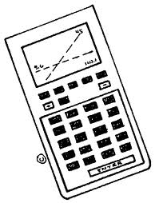
- The examination consists of 6 questions in total.
- The answers to each question must be supported by detailed working.
- Answers given without supporting evidence may not be awarded marks.
- Answer all questions in the spaces provided in this booklet.

Stay calm and focussed.
Believe in yourself!
Exercise B1 | Scale
A patient takes some medication at midday. The amount of drug, $D$ mg, remaining in their bloodstream $h$ hours after midday is modelled by the formula:  $$D=0.06+0.5h-0.1h^{2} 0≤h≤5$$ | 11 Marks
- Determine the amount of drug that is already naturally occurring in the patient’s bloodstream at the moment they take the medication. | 1
- Calculate how long it takes for the amount of the drug in the patient’s bloodstream to return to its natural level. | 2
- Determine the time when the amount of drug in the patient’s bloodstream will be a maximum. | 3
- It is safe for the patient to take more medication once the amount of drug in their bloodstream falls below 0.46 mg. Determine the earliest time that a patient can take a second dose of the medication. | 3
- Explain why your answer to (d) should not be 1 pm despite this being a solution to the relevant equation? | 2

Exercise B2 | Scale
Consider the following equation: $\log\left(x-2\right)+\log\left(x+3\right)=2$  - Solve the equation showing all stages of your working and giving the solution(s) as an exact value.  - Write the solution(s) of the equation as a decimal giving your answer(s) to an accuracy of 1 decimal place. | 6 marks  5  1

Exercise B3 | Scale
Using the data in the picture:  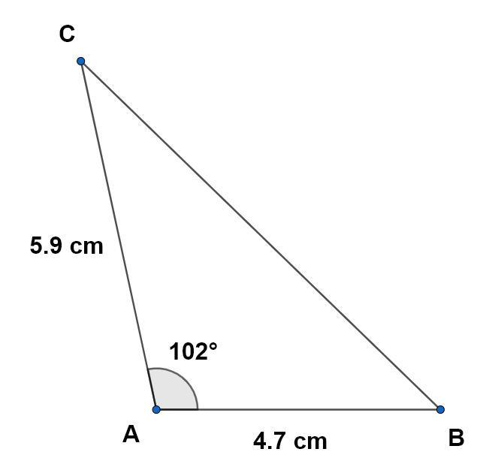 | 11 Marks
- Give the length of the missing side accurate to one decimal place. | 3
- Calculate the sizes of the angles of the triangle, giving the results to an accuracy of one decimal place. | 5
- Calculate the area of this triangle, giving the result to an accuracy of one decimal place. | 3

Exercise B4 | Scale
In a 2-dimensional orthogonal coordinate system, the coordinates of the points A,B and C are (1,4), (5,5) and (-1,6) respectively. | 10 Marks
- Determine the vector $\vec{AB}$ and calculate its magnitude. | 2
- Determine the magnitude of the vector $\vec{AC}$ | 2
- Calculate the size of the angle between $\vec{AB}$ and $\vec{AC}$ giving your answer in degrees to 1 dp. | 3
- Determine the value of k that makes the vector $\left(\begin{matrix}k \\ 1\end{matrix}\right)$ perpendicular to vector $\vec{BC.}$ | 3

Exercise B5 | Scale
Consider the following block of feta cheese with the dimensions $6 cm×10 cm×4 cm$ as shown in the rectangular cuboid below:  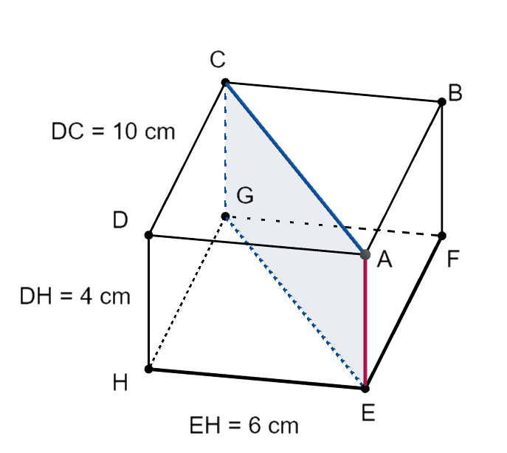  To decorate a salad, the cheese is cut in half diagonally from AC vertically downwards. | 7 Marks
- Show that the length of the cut $\left|AC\right|$ accurate to two decimal places is 11.66 cm. | 2
- Determine the length of the diagonal $\left|AG\right|$ accurate to two decimal places. | 2
When the cheese is cut, 0.5% of the volume is lost on the knife.

- Calculate the volume of the cheese after the cut. | 3

Exercise B6 | Scale
In a manufacturing company, employee satisfaction is studied in relation to two aspects: working conditions (C) and career opportunities (O). A study shows that 60% of employees are satisfied with their working conditions, 50% are satisfied with their career opportunities and 40% are satisfied with both their working conditions and career opportunities. | 9 Marks
- Construct a suitable diagram to summarize the results of the survey. | 3
- Calculate the probability that a randomly selected employee is satisfied with their career opportunities given that they are also satisfied with their working conditions. | 2
- Calculate $P(\overline{O})$. | 1
- The director of the company claims that whether an employee is satisfied with their working conditions is independent from their satisfaction of career opportunities. Is the director correct? Justify your answer. | 3

END OF THE EXAMINATION

