MATHEMATICS 3 PERIODS
PART A

DATE: January, Monday the 29th, 2024
TIME ALLOWED FOR THE EXAM:  2 hours (120 minutes)  AUTHORISED MATERIAL:  ● Examination without technological tool  ● Pencil for the graphs  ● Formula booklet  PARTICULAR REMARKS: | 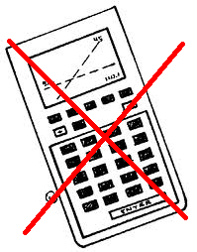
● Answers must be supported by explanations.
● Full marks will not be awarded if a correct answer is not accompanied by supporting evidence or explanations of how the results or the solutions have been achieved.
● When the answer provided is not the correct one, some marks can be awarded if it is evident that an appropriate method and/or a correct approach has been used.
NUMBER OF EXAM DOCUMENTS: 2
EXAM DOCUMENTS:
EXAM PAPER | YES ⊠ NO ☐
ANSWER BOOKLET | YES ☐ NO ⊠
FORMULA BOOKLET | YES ⊠ NO ☐

NUMBER OF PAGES OF THE EXAM PAPER: 6

REMINDER: NO ANSWERS TO BE WRITTEN ON THE EXAM PAPER

NAME OF TEACHERS: S. ANGELOZI, Y. BARSAMIAN, K. HANSEN, A. HARSÁNYI, M. PÉREZ PÉREZ, C. PETRUZ, O. PICAUD, J. SZUTY, L. WURZER.

NAME OF PUPIL: …………………………………

PART A
 |  | Page 1/4 | Marks
1) | The diagram below shows the graph of a function $f$ and that of its derivative function $f'$.
 | 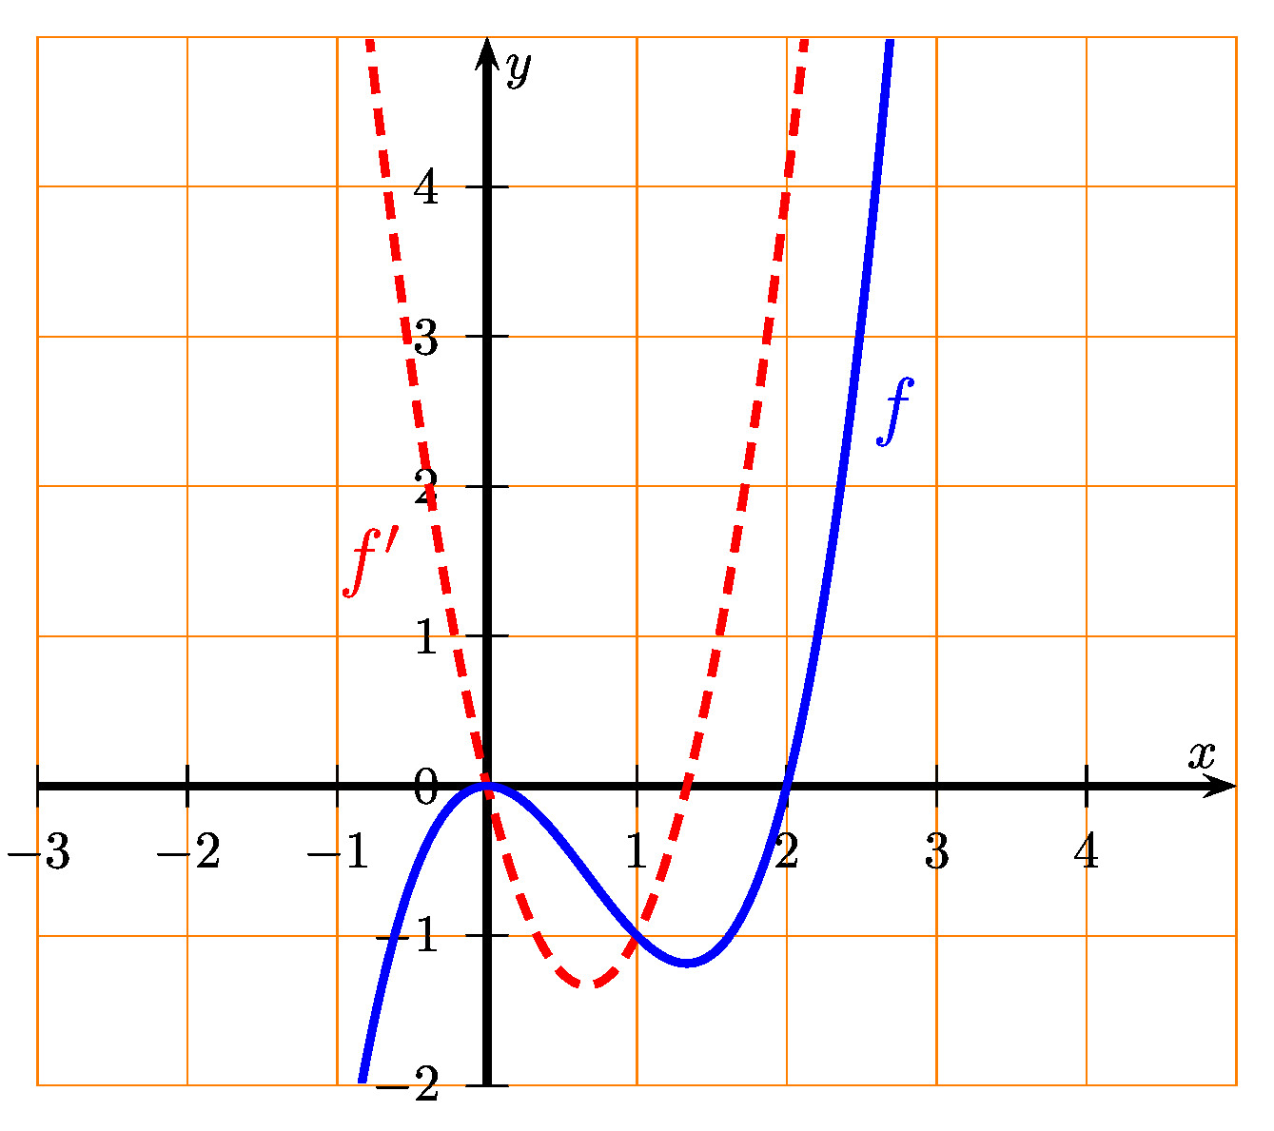
 | a) Find the value of $f\text{(}2\text{)}$ and $f'\text{(}2\text{)}$. |  | 2 marks
 | b) Determine an equation of the tangent to the graph of $f$ at the point where $x=2$. |  | 3 marks
2) | The diagram shows the graph of the derivative $f'$ of a function $f$.
 | 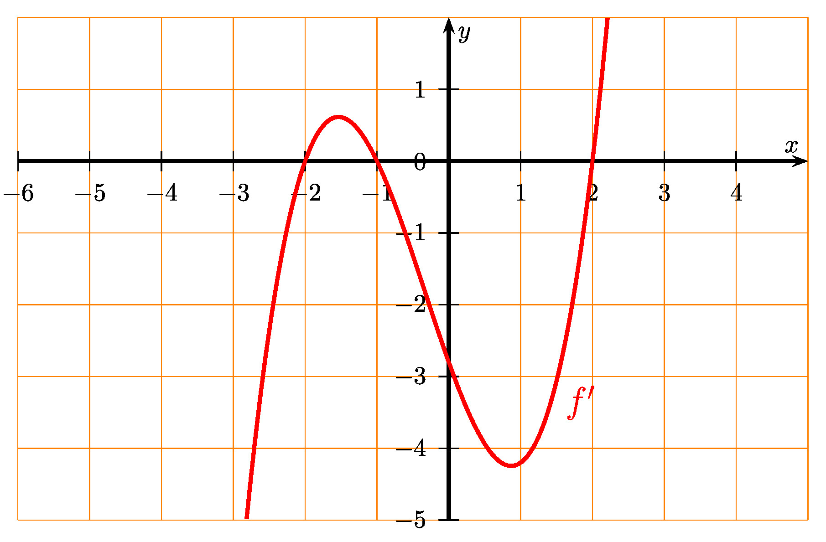
 | a) Give the intervals on which the function $f$ is increasing. |  | 2 marks
 | b) Determine whether the function $f$ has a local maximum. Justify your answer. |  | 3 marks

PART A
 |  | Page 2/4 | Marks
3) | Consider the function $f$ defined by $f\text{(}x\text{)}=3x^{3}−2x^{2}−1$.  Consider also the function $F$ defined by $F\text{(}x\text{)}=a⋅x^{4}+b⋅x^{3}+c⋅x+d$, where $a$, $b$, $c$ and $d$ are four real numbers.
 | a) Find the values of the three parameters $a$, $b$, and $c$ such that $F'=f$. |  | 3 marks
 | b) Find the value of the parameter $d$ such that $F\text{(}1\text{)}=\frac{1}{12}$. |  | 2 marks
4) | Here is the curve of the function $f$ defined by:  $$f\text{(}x\text{)}=x^{2}−2x+2$$
 | 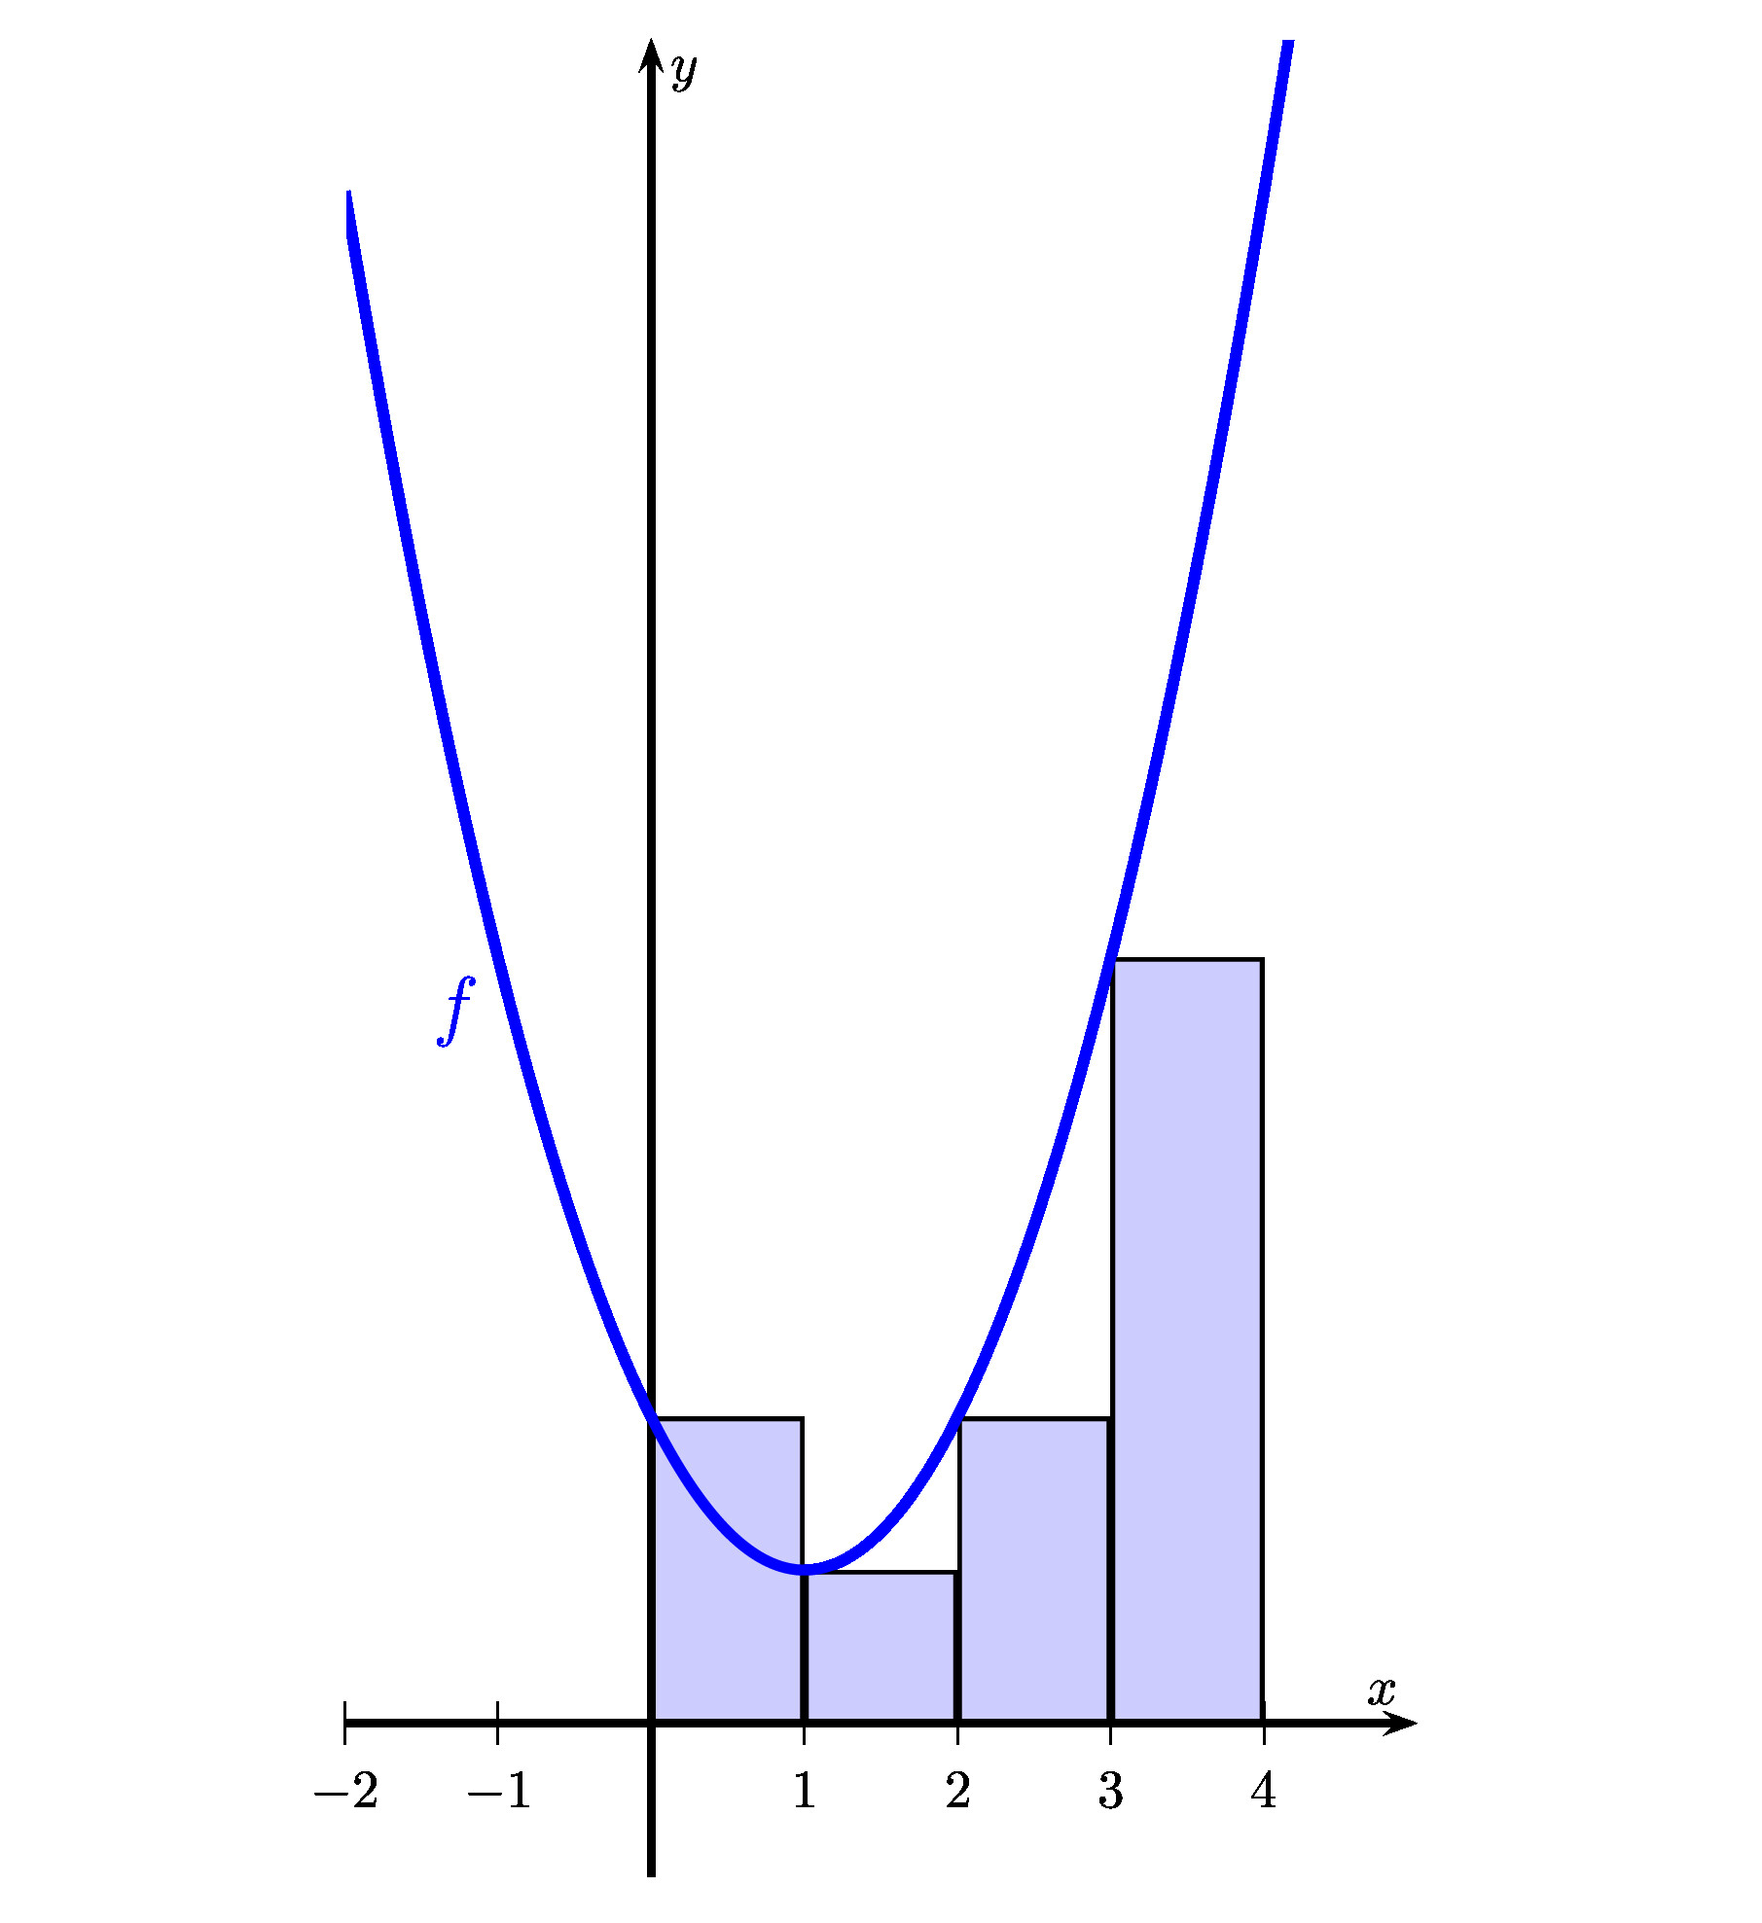
 | a) Find an approximation of the area under the curve from $x=0$ to $x=4$ by using left sided rectangles of width 1. |  | 3 marks
 | b) Based on the graph, discuss if this approximation is an over-estimation of $\int_{0}^{4}{f\text{(}x\text{)}dx}$, or an under-estimation. Justify your answer. |  | 2 marks

PART A
 |  | Page 3/4 | Marks
5) | The graph below shows a periodic function $f$, defined by:  $$f\text{(}x\text{)}=a∙sin\text{(}b\text{(}x−c\text{)}\text{)}+d$$  (where $a$, $b$, $c$ and $d$ are four real numbers).
 | 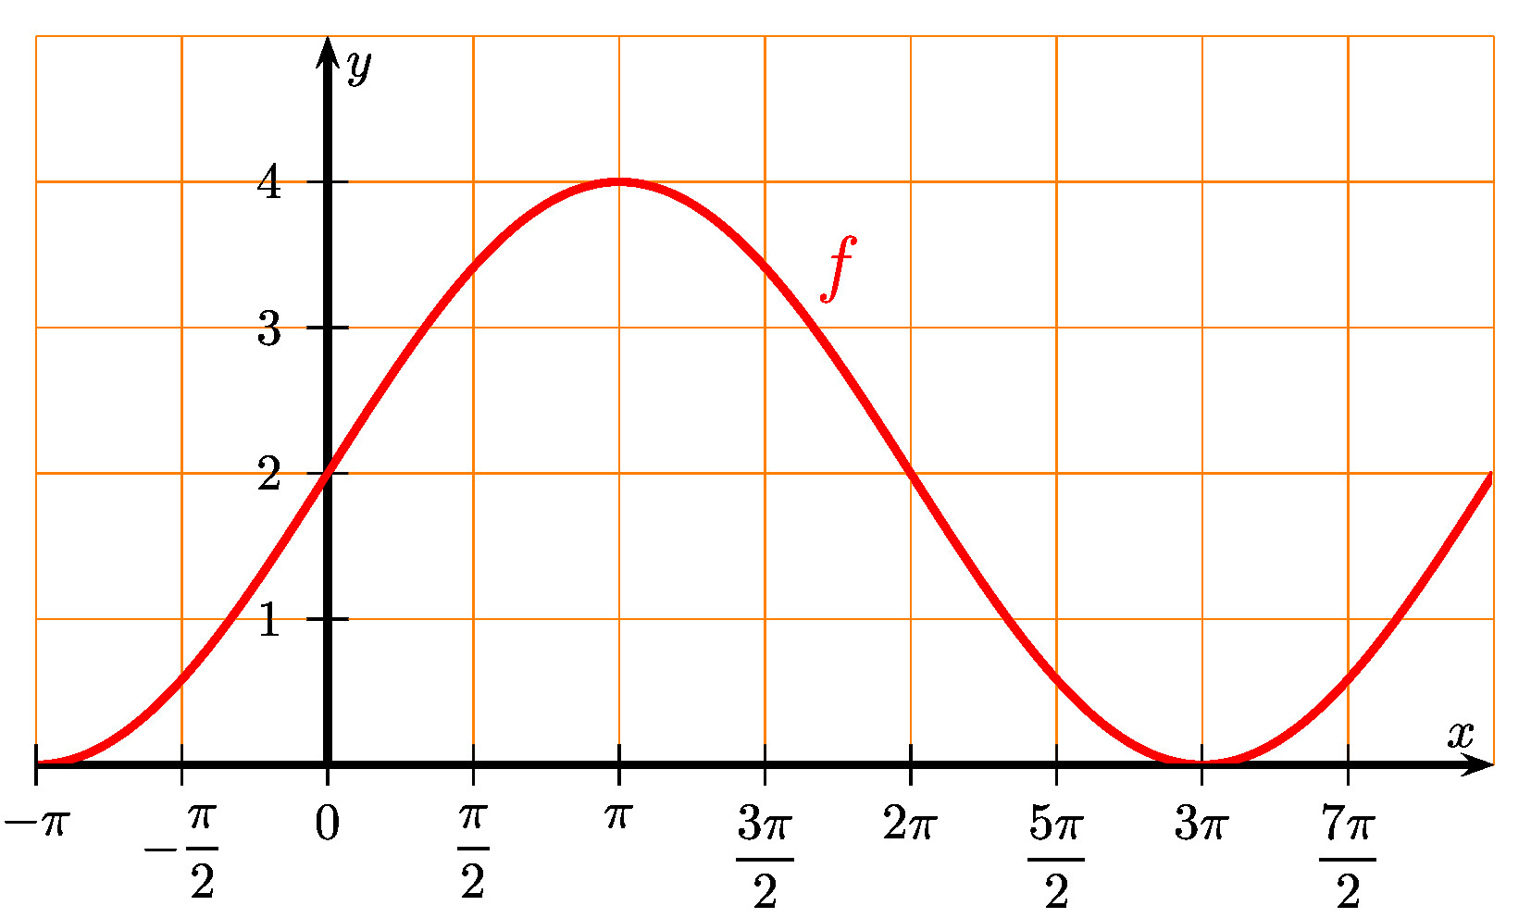
 | Based on the information in the graph,  • determine the amplitude, the period and the vertical shift of $f$, then give the values of $a$, $b$ and $d$.  • find $f\text{(}π\text{)}$ and $f\text{(}9π\text{)}$. |  | 5 marks
6) | Let us consider the function $f$ defined by:  $$f\text{(}x\text{)}=\frac{1}{x}$$  We recall that the function $F$ defined by $F\text{(}x\text{)}=ln\text{(}x\text{)}$ is a primitive of $f$.
 | Calculate the area under the curve of $f$ from $x=1$ to $x=\text{e}$. |  | 5 marks
7) | Two brothers, Jarek and Kuba, wash the dishes after each dinner. Kuba is older and the probability that he washes the dishes after dinner is 4/7.  When Kuba washes the dishes, the probability of breaking a plate is 2/100. When Jarek washes the dishes, this probability is 1/100.  We select a dinner at random.
 | a) Draw a tree diagram of the situation described. |  | 2 marks
 | b) A plate is broken during the washing of the dishes after the selected dinner. Calculate the probability that Kuba washed the dishes. |  | 3 marks

PART A
 |  | Page 4/4 | Marks
8) | In a certain class, 60% of the students have a cat, 50% of the students have a dog. We also know that 30% of the students have both a dog and a cat. We select a student at random in this class and we consider the following two events:  Event $A$ – the student has a dog,  Event $B$ – the student has a cat.
 | a) Determine if the events $A$ and $B$ are independent. Justify the answer. |  | 2 marks
 | b) Calculate $P\text{(}A∪B\text{)}$. |  | 3 marks
9) | A player throws at a dartboard 4 times in a row. For each throw, the player hits the bull’s eye in the center of the dartboard with a probability of 1/4. The random variable $X$ indicates how often the player hits the bull's eye.
 | a) Explain why the random variable $X$ follows a binomial distribution and give its parameters. |  | 2 marks
 | b) Calculate the probability that the player hits the bull’s eye exactly three times. |  | 3 marks
10) | The data presented in the table below describes the growth of a cactus. This type of plant can grow to be maximum 5 meters tall.  $x$ = Year after planted 0 1 2 3 4 5 6  $y$ = Height (m) 0 0.6 1.3 1.7 2.2 2.5 2.9
 | a) Draw a scatterplot for this data. Use an appropriate scale. |  | 2 marks
 | b) Knowing that the data describes the growth of a cactus that can maximum become 5 meters high. Discuss what kind of regression model would describe the data best. Justify. |  | 3 marks

END OF THE EXAMINATION

