MATHEMATICS 3 PERIODS
PART B

DATE: January, Monday the 29th, 2024
TIME ALLOWED FOR THE EXAM:  2 hours (120 minutes)  AUTHORISED MATERIAL:  ● Examination with technological tool: Approved calculator  ● Pencil for the graphs  ● Formula booklet  PARTICULAR REMARKS: | 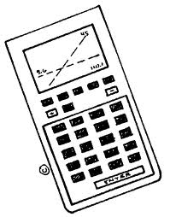
● Answers must be supported by explanations.
● Full marks will not be awarded if a correct answer is not accompanied by supporting evidence or explanations of how the results or the solutions have been achieved.
● When the answer provided is not the correct one, some marks can be awarded if it is evident that an appropriate method and/or a correct approach has been used.
NUMBER OF EXAM DOCUMENTS: 2
EXAM DOCUMENTS:
EXAM PAPER | YES ⊠ NO ☐
ANSWER BOOKLET | YES ☐ NO ⊠
FORMULA BOOKLET | YES ⊠ NO ☐

NUMBER OF PAGES OF THE EXAM PAPER: 8

REMINDER: NO ANSWERS TO BE WRITTEN ON THE EXAM PAPER

NAME OF TEACHERS: S. ANGELOZI, Y. BARSAMIAN, K. HANSEN, A. HARSÁNYI, M. PÉREZ PÉREZ, C. PETRUZ, O. PICAUD, J. SZUTY, L. WURZER.

NAME OF PUPIL: …………………………………

PART B
QUESTION B1 |  |  | Page 1/3 | Marks
In this question, parts 1, 2 and 3 are independent.

Part 1.  Sports watches are wristwatches that can be used during sporting activities. A lot of people use those watches.  The so-called Sporty sports watch is particularly popular. The probability that a random person with a sports watch has the watch Sporty is 60 %.  We are looking at a sample of 500 people with sports watches. The random variable $X$ gives the number of people in this sample that have the sports watch Sporty. |  | 
a) | Explain why $X$ can be modelled by a binomial law and give its parameters. |  |  | 2 marks
b) | Calculate the probability that at least 300 people in this sample have the sports watch Sporty. Round to 2 decimal places. |  |  | 2 marks
c) | Determine the expected number of people in this sample with the sports watch Sporty. |  |  | 2 marks
d) | Calculate the standard deviation of $X$. Round to 3 decimal places. Interpret it in the given context. |  |  | 2 marks

PART B
QUESTION B1 |  | Page 2/3 | Marks
Part 2.
The sports watch Sporty can give the effort during a run very accurately if the person gives his or her weight.

A woman with a weight of 60 kg is running uphill for 30 minutes. Therefore, her effort level is not steady. Her running power can be modelled by the following function:

$P\left(t\right)=−0.05t^{2}+3t+66$, with $0≤t≤30$

where $t$ is in minutes and $P\left(t\right)$ in kJ/min (kilojoules per minute).
e) | Calculate at which power the woman is running when she starts running, and 15 minutes after she started. |  | 3 marks
f) | Draw the graph of the function $P$ in the given definition set. |  | 3 marks
g) | Determine at what time the woman’s running power is 106 kJ/min. |  | 3 marks

PART B
QUESTION B1 |  | Page 3/3 | Marks
Part 3.
A lot of people are using the internet to buy their sports watch Sporty, and ask for a delivery at a shop called “RunAway”.

We know that 80% of the time the Sporty arrives on time (in a few days), 15% of the time it arrives late (it takes some weeks to arrive) and the rest of the times it doesn’t arrive at all.

We also know that when the Sporty arrives on time, the probability that people like the shop “RunAway” is 0.9; when it arrives late, the probability that people like it is 0.3; and if it doesn’t arrive at all the probability that people like the shop is 0.1.

We randomly select a user who ordered a Sporty watch online and asked for delivery in this shop.
h) | Sketch a tree diagram of the situation above. |  | 3 marks
i) | Compute the probability that this user likes the shop “RunAway”. |  | 2 marks
j) | If we know that this person liked the shop, give the probability that the Sporty that was ordered arrived on time. |  | 3 marks

PART B
QUESTION B2 | Page 1/3 | Marks
In this question, parts 1 and 2 are independent.

Part 1.
A musician plays a guitar and wishes to model its shape. The main wood box can be modeled by the following equation:
$$f\left(x\right)=−0.13x^{4}+1.4x^{3}−4.9x^{2}+6x$$
The following picture shows the curve of $f$ (in red, plain line), together with the symmetric of this curve, with respect to the $x$-axis (in blue, dashed line). In this equation, $x$ is in decimetres, and $f\left(x\right)$ is also in decimetres. The surface between those two curves forms the wood box of this guitar.
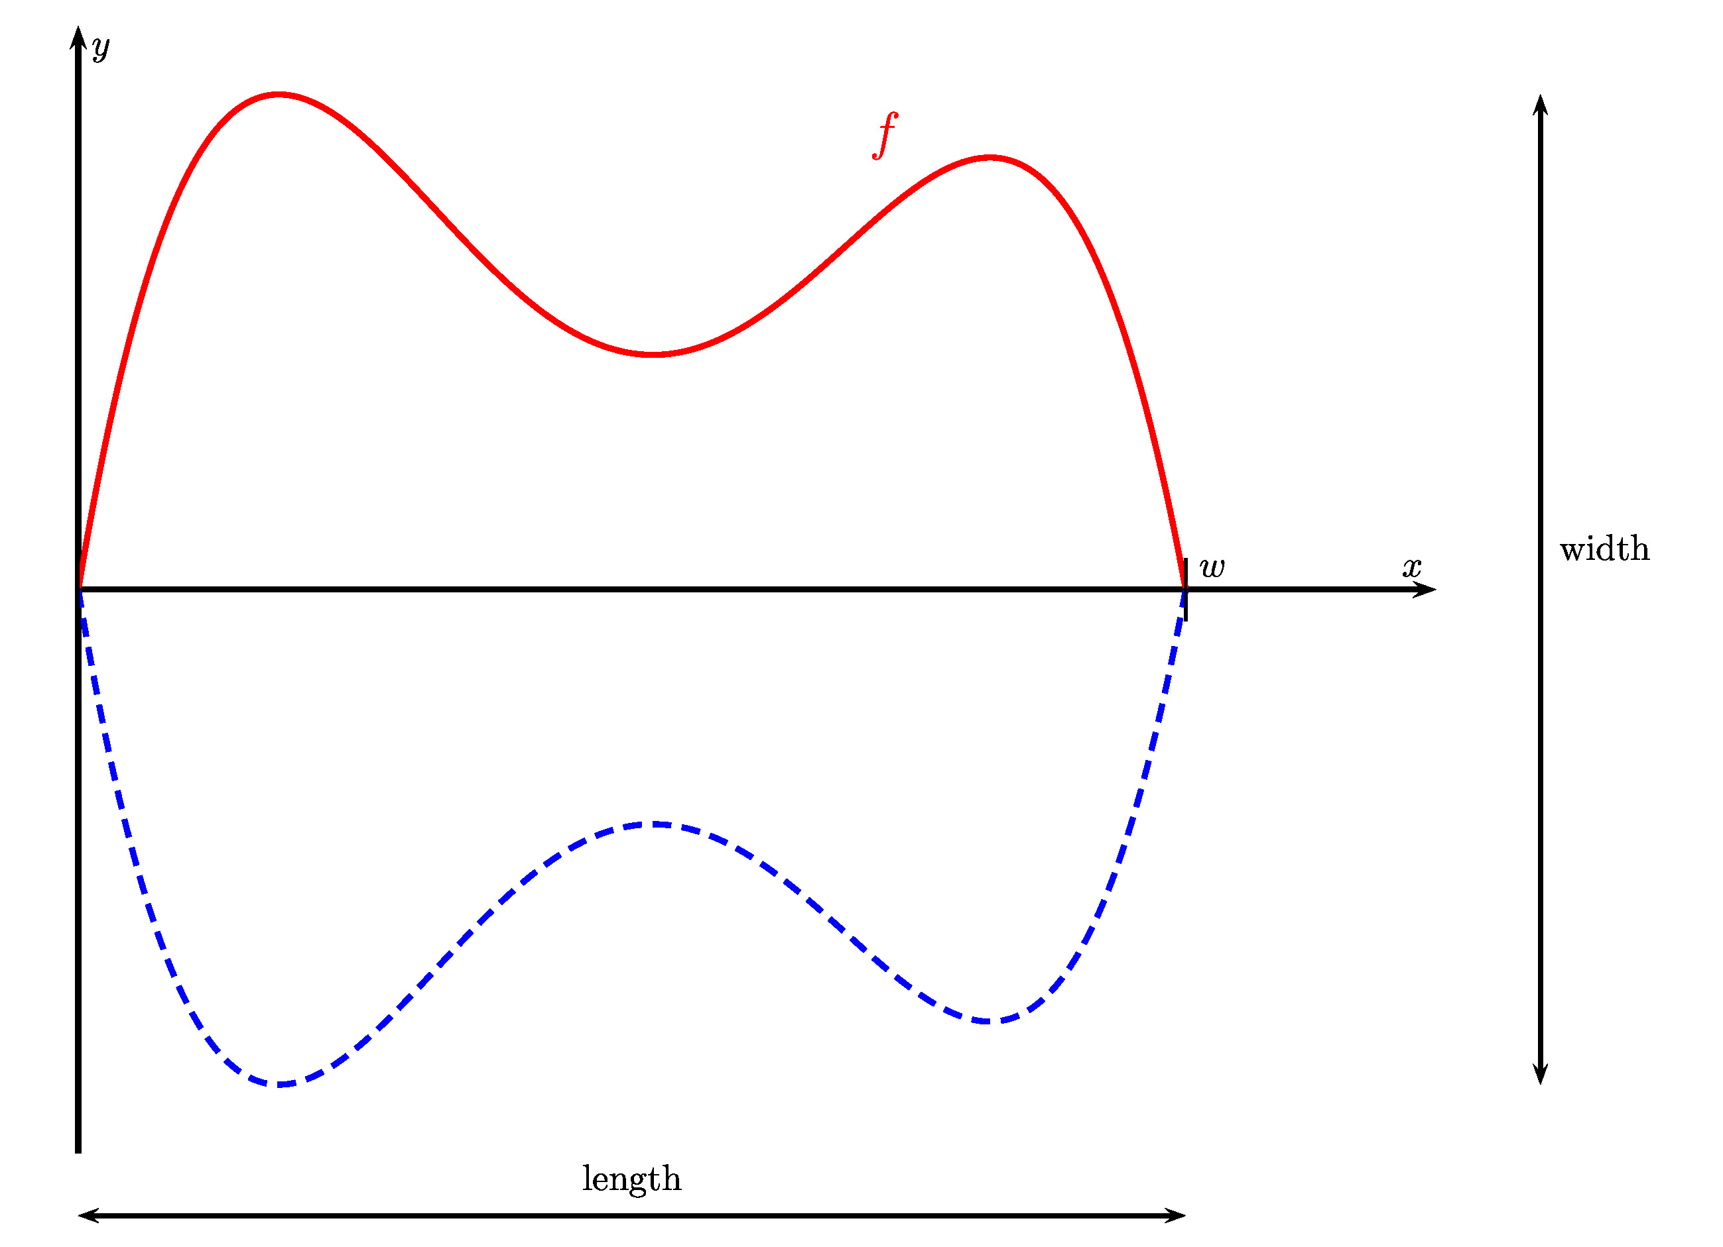
As can be seen on the graph, the function $f$ is in fact defined from $0$ to a value $w$, which is the other solution of the equation $f\left(x\right)=0$.

PART B
QUESTION B2 |  | Page 2/3 | Marks
a) | Determine the value of $w$, rounding to 3 decimal places. Give the length of the wood box, in centimetres. |  | 2 marks
b) | Determine the maximum value of $f$, rounding to 3 decimal places. Give the width of the wood box, in centimetres. |  | 2 marks
c) | The function $f$ has three stationary points. In question b) we have found one of them. Give the coordinates of the two other stationary points, rounded to two decimal places. |  | 4 marks
Before a big concert, our musician wants to paint the back of the wood box in black. We hence want to know what is the area of this surface.
d) | Determine an approximate value of the following integral, rounded to 3 decimal places:  $$\int_{0}^{5.3}{f\left(x\right)dx}$$  Give the area that has to be painted, in square decimetres. |  | 3 marks

PART B
QUESTION B2 |  | Page 3/3 | Marks
Part 2.
Our musician opens a webpage for his band, and is interested in the number of followers across time ($x=0$ when the webpage is created). The table below shows the number of followers for the first 20 weeks:
$x$ = Time (weeks) | 2 | 4 | 5 | 8 | 10 | 11 | 12 | 13 | 16 | 18
$y$ = Number of followers | 275 | 240 | 180 | 300 | 380 | 350 | 250 | 350 | 440 | 400

e) | Draw a scatter diagram to represent the data from the table. |  | 3 marks
f) | Compute the linear correlation coefficient. Determine if a linear model would be appropriate for his data. Discuss how we could improve the linear model by combining it with another one. |  | 3 marks
g) | Determine an equation in the form $y=a⋅x+b$ of the linear regression of $y$ on $x$ using this data. Round $a$ and $b$ to one decimal place.  Draw the regression line on the same diagram as e). |  | 3 marks
In h) and i), use the linear model $f\left(x\right)=20⋅x+190$.
h) | Compute when the number of followers would be over 800. |  | 3 marks
i) | Explain why the model is not appropriate over many weeks. |  | 2 marks

END OF THE EXAMINATION

